

CENTENNIAL COLLEGE PROGRESS CAMPUS

COURSE COMP125 Winter 2020

ASSIGNMENT #3

DOM

Modify the chapter 5 example (photo viewer) to include the following features:

1. When the user clicks on a picture and it opens a window containing a zoomed version of the image, give her a hyperlink (button) to add the pic to a favorites’ area at the bottom of the first page (add img nodes to the DOM).
2. A maximum of 5 pics can be added to the favorites. After that a message is displayed to remove at least a favorite first.
3. If the user clicks on a favorite, a Remove link (button) shows up next to that picture. If the user clicks it, the pic is removed from the favorites.
4. (**10% of the grade**) Use good web design practices to enhance visually your html page. Add a title, picture, copyright line, etc.

Basic screenshots for the functionality of this assignment are shown below:

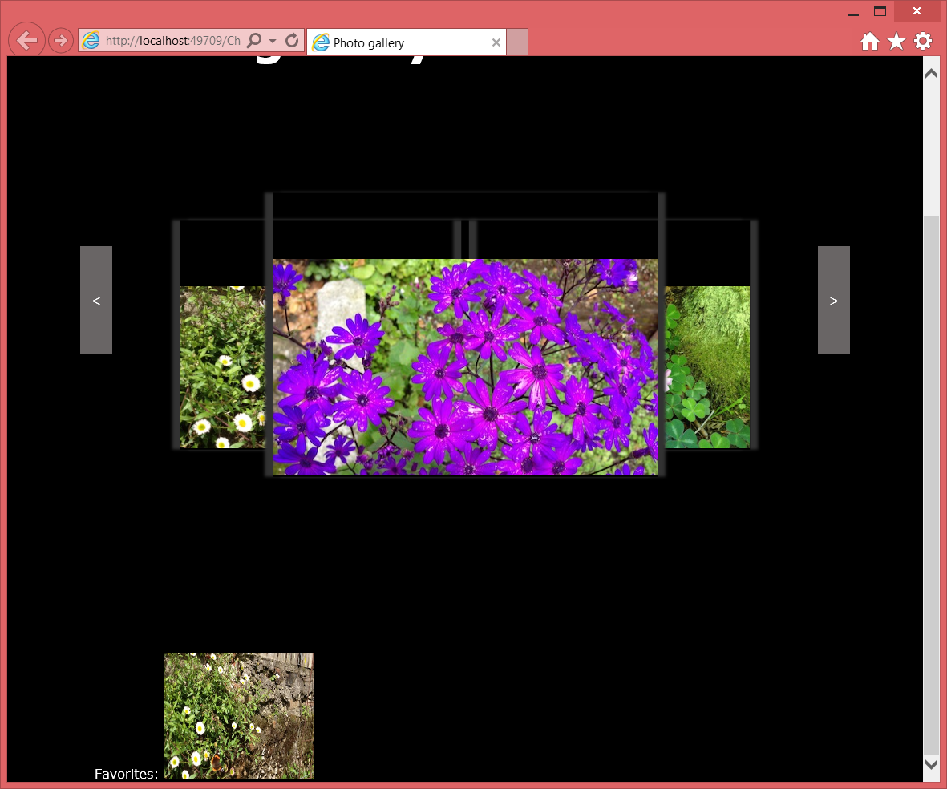

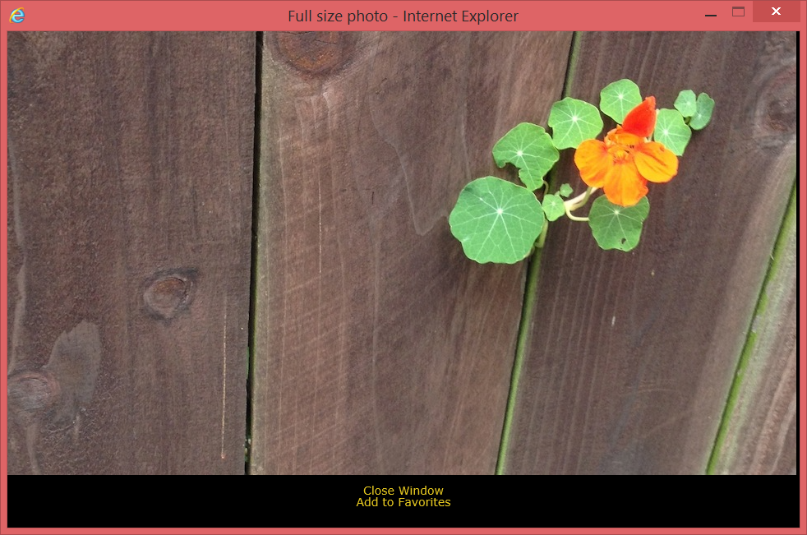

Important Notes:

1. This assignment is **due on FEB 26th at 11:30 pm**.
2. **Late assignments are accepted seven more days after the due to date and they are marked out of 75%**.
3. Submit your assignment to Assignment 3 drop box.
4. ALSO PUBLISH IT to the student web

Note:

* Remember to test it using Internet Explorer.
* Or using Google Chrome you have to follow the instructions in this link to disable Web Security: <https://stackoverflow.com/a/42024918>